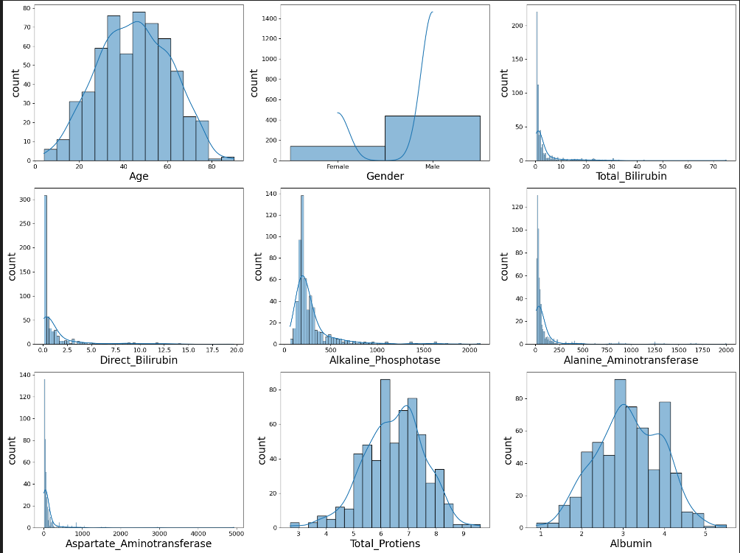

**Age Distribution**

* The **age distribution** appears **approximately normal** with a slight right skew.
* Most individuals fall within the **30-50 age range**, with fewer in the younger and older categories.

**Gender Distribution**

* There is a clear imbalance, with significantly more **males** than **females** in the dataset.

**Total Bilirubin & Direct Bilirubin**

* Both features are **highly right-skewed**, meaning most individuals have **low bilirubin levels**, while a few have significantly high levels.
* This suggests potential **outliers or liver-related conditions** in certain cases.

**Alkaline Phosphatase, Alanine Aminotransferase & Aspartate Aminotransferase**

* These liver enzymes also exhibit **strong right skewness**, indicating that **most people have low enzyme levels**, but a few cases show **extremely high values**.
* This could indicate **liver diseases** such as hepatitis or liver damage.

**Total Proteins & Albumin**

* These features have **nearly normal distributions**, suggesting a **balanced range of protein levels** in the dataset.
* There might be slight variations, but no extreme skewness is observed.